**SCILOGEX Vacuum Aspiration Systems**

***User*** ***manual***

**4L Vacuum Aspiration System with Quick-Release Cap**

**2L Vacuum Aspiration System with Barbe Tube Fittings Cap**

**Contents**

Contents 2

Product Description 3

Repair Service 3

Warranty Information 4

1. Safety Information 5

2. Inspection, Package contents 6

2.1 Unpacking 6

2.2 Packing List 6

3. Product Overview 7

4. Operation 9

8. Maintenance, Care, and Safety 10

9. Troubleshooting 12

10. Specifications 13

**Product Description**

Thank you for your recent purchase of this Vacuum System. The 4L Vacuum Aspiration System/2L Vacuum Aspiration System is a vacuum system with an integral pump and adjustable, electronic vacuum controller for laboratory use.

The instrument should not be used for applications other than those specified.

**Repair Service**

If Should the 4L Vacuum Aspiration System/2L Vacuum Aspiration System require service or repair, please contact Supplier Customer Service. A Return Authorization Number will be issued and customer will be advised on proper packing and method of shipment.

**Warranty**

This 4L Vacuum Aspiration System/2L Vacuum Aspiration System Vacuum Aspiration System is warranted to be free of defects in materials and workmanship

for a period of 24 months from date of purchase, provided that:

• The unit has not been opened or attempted to be opened by the end user

• The user ensures that it has been carefully cleaned and decontaminated

• The unit has been operated according to the instructions and not in any improper way

Should warranty service be required, repair or replacement will be provided by supplier

without charge. Freight charges for shipping unit to supplier will be responsibility of purchaser.

|  |  |
| --- | --- |
| Adapter with Ejection Device,  Single-Channel, 1.0mL tip | 1 |
| Adapter with Ejection Device,  Single-Channel, 200uL tip | 1 |
| Adapter, Eight-Channel Needle,  Stainless Steel | 1 |
| Adapter with Ejection Device, EightChannel | 1 |
| Adapter, Single-Channel Needle,  Stainless Steel (4 sizes) | 4 |
| Handle Hoop | 1 |
| Power Adapter 100V-220V, 50Hz/60Hz  for EU, UK, North America (3) | 1 |
| Level Detection Sensor cable only with the 4L Vacuum Aspiration System | 1 |

**2.** **Inspection**

2.1 Unpacking

After unpacking, please contact supplier

if you find any damage to content.

|  |  |
| --- | --- |
|  | **Note**：  If there is any visible damage on the instrument, do not connect to power supply. |

2.2 Package Contents

|  |  |
| --- | --- |
| Description | **Quantity** |
| base unit | 1 |
| Vacuum Bottle: 2L or 4L depending on model | 1 |
| Hand Operator Bracket | 1 |
| Cap: Quick Release Couplings Cap or Barbed Fittings Cap depending on model | 1 |
| Tubing for Connection of Base to Cap | 1 |
| Tubing for Connection from Cap to Hand Operator | 1 |
| Aspiration handle | 1 |

1. **Product Overview**

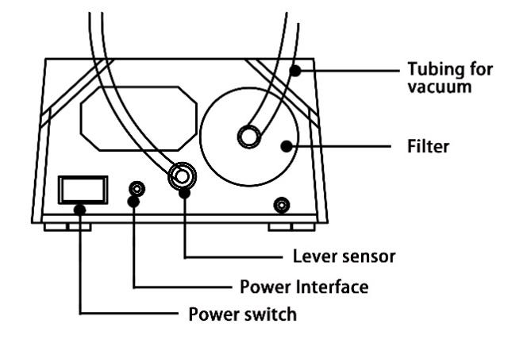**Model 4L Vacuum Aspiration System**

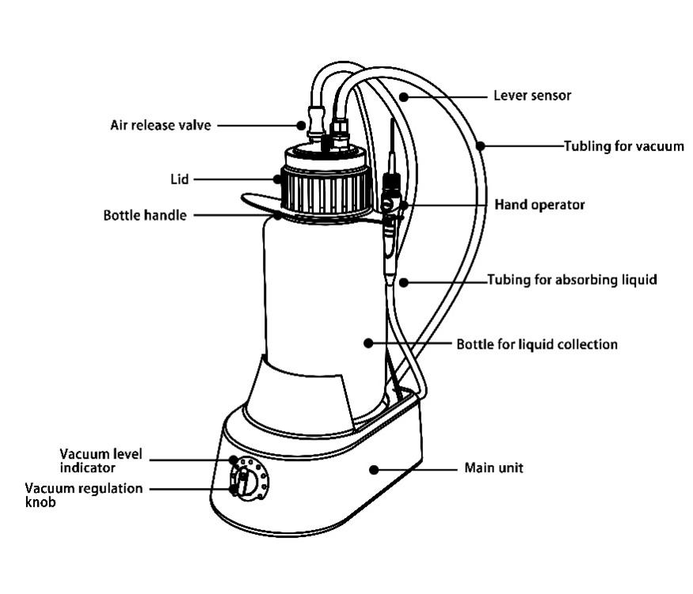

**Handle continuous**

**Dispensing mode**

Level 1

*30% increase in aspiration rate*

Level 2

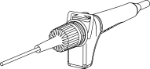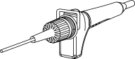

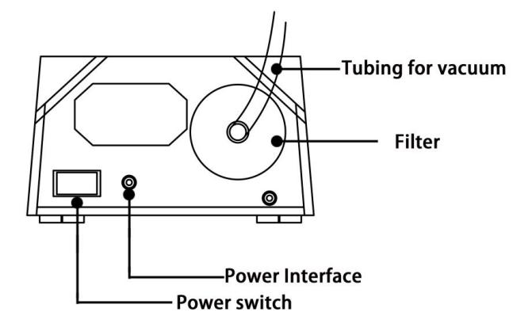 **Model 2L Vacuum Aspiration System**

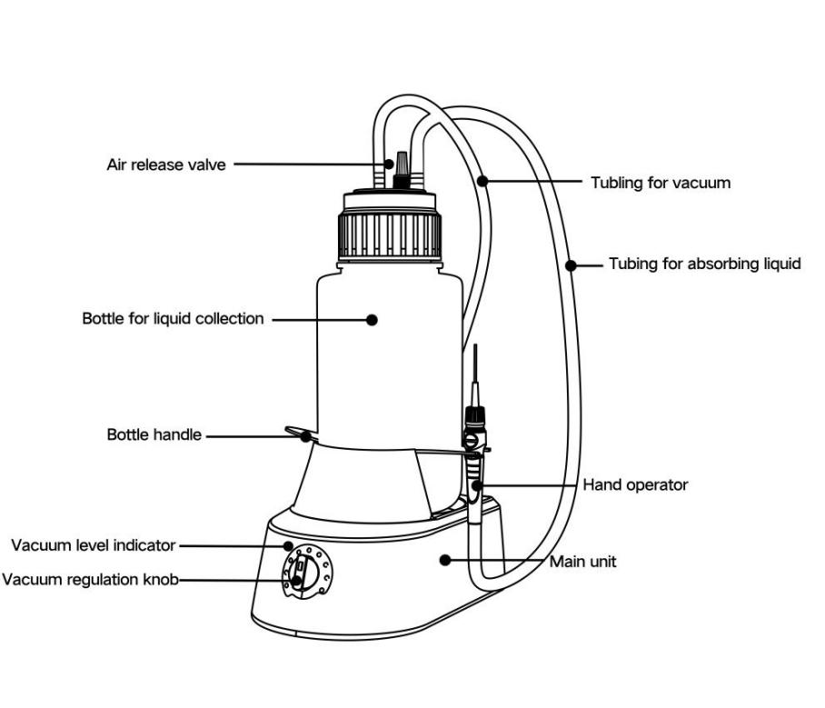

**Handle continuous**

**Dispensing mode**

Level 1

*30% increase in aspiration rate*

Level 2



1. **Getting Started**

Please ensure that all packaging materials have been removed before using the 4L Vacuum Aspiration System. Place the 4L Vacuum Aspiration System unit on a dry, level, dust-free location. Power Supply Connection

• Plug the mains adapter into a standard electrical source

and connect to the 4L Vacuum Aspiration System.

**5. Operating the 4L Vacuum Aspiration System/2L Vacuum Aspiration System Vacuum Aspiration System**

**Preparing Vacuum Bottle**

• Fit lid with quick release couplings onto bottle. Ensure that lid is firmly attached.

**Connecting Vacuum Bottle to Instrument**

• Connect filter with short tube to the instrument base and connect other tube end to the bottle cap coupling.

**Connecting Vacuum Bottle to Hand Operator**

• Connect other tube with coupling from bottle cap to hand operator.

**Connecting the Level Detection Sensor Cable**

• Connect level detection sensor cable to the instrument base and connect other end to bottle cap

**6. Operation**

Please read the following notes before attempting to

operate the 4L Vacuum Aspiration System/2L Vacuum Aspiration System

 **NOTE**

Always attach lid on tightly, ensuring that screw threads are properly aligned. The seal in the lid will only function correctly when adequately compressed.

Make sure discharge valve is closed by turning clockwise or vent cap is sealed on the 2L Vacuum Aspiration System.

• Turn the power switch on back of instrument base to “ON” (I).

• Turn the regulator knob clockwise; set the vacuum level.

The lights will become steady indicating that the system

has reached the desired vacuum. Vacuum increases as the regulator knob is turned clockwise.

• Press the button on the hand operator to start suction.

1. **Shut down**

• Turn the power switch on back of instrument base to

“OFF” (O).

• Loosen the discharge valve by turning counterclockwise or unplug vent if using the 2L Vacuum Aspiration System.

• Unplug all cable and tubes from cap and remove cap from

the bottle.

• Discard any waste from the bottle.

**8. Maintenance, Care and Safety**

**Precautions**

**Maintenance**

The 4L Vacuum Aspiration System / 2L Vacuum Aspiration System does not require any special servicing or maintenance. If a reduction in suction power occurs, it may be caused by blockages in the tube and/or filter on the pump side.

This may be remedied by exchanging the affected tube and/or filter.

**Care**

The 4L Vacuum Aspiration System / 2L Vacuum Aspiration System may be cleaned

with most common laboratory disinfectants, including

isopropanol.

**NOTE**

When using level detection, always ensure that the contact pins on bottle lid are kept clean and dry.

**DANGER**

Always unplug the 4L Vacuum Aspiration System / 2L Vacuum Aspiration System from power supply before cleaning. Never use caustic solutions (such as nitro thinners) to clean the unit.

**9. Troubleshooting (FAQ)**

|  |  |  |
| --- | --- | --- |
| **Problem** | **Possible Cause** | **Remedy** |
| Equipment not running; no vacuum | No power line voltage | Insert mains adapter plug into suitable power outlet |
| No DC supply | Connect mains adapter to instrument |
| Pump switched off | Turn power switch to “ON” (l). Ensure that LED indicator under bottle is lit |
| Suction power inadequate or pump runs constantly | Suction power selected too low | Turn control knob clockwise |
| Leak in vacuum system | Check tubes and filters |
| Check lid and tighten if necessary |
| Check if sealing plug/venting screw on bottle lid is leaking |
| Ensure that filter is fully tightened on to unit |
| Ensure that leak flow of hand tool is not excessively high |
| Bottle full; liquid is sucked into filter | Remove wet filter and replace with new, dry filter |
| Empty excess liquid from existing bottle or replace with new, empty bottle |
| Tubes Blocked | Clean or replace tubes |
| Alarm level detection not working ( 4L Vacuum Aspiration System) | Sensor cable incorrectly connected | Check that cable is correctly connected to device and lid |
| Liquid in bottle has reached the sensor | Empty excess liquid from bottle |

12

1. **Specifications**

|  |  |
| --- | --- |
| Voltage | 100 – 240 VAC, 50/60 Hz |
| Vacuum range | 0 to 600 mbar (adjustable) |
| Pumping speed | 15 L/min (air) |
| Aspiration rate | 17 ml/s (aspiration pipette) |
| Noise | < 55 dB(A) (1 Meter) |
| Size (H x W x D) | 180x240x450mm ( 4L Vacuum Aspiration System)  180×240×340 mm (2L Vacuum Aspiration System) |
| Weight | 3kg ( 4L Vacuum Aspiration System)  2.8kg (2L Vacuum Aspiration System) |
| Pollution Degree | 2 |
| Relative humidity | 50% |

**SCILOGEX.COM**

13